Kettering Health Network

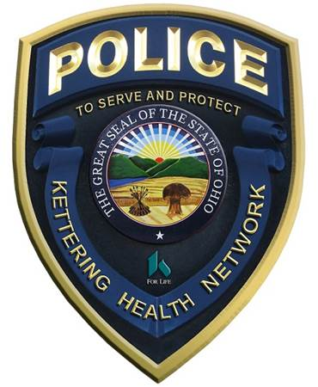

Police Department

Acceptance of Patient Property

Name of Person Dropping off Property: _________________________________

Phone: _________________________________

Name of Patient___________________________ Name of Hospital: ________________________

Date: ______________________ Time: _____________ am / pm
Due to heightened concerns of the potential spread of COVID-19, items being delivered to patients at KHN facilities will be limited to items considered essential to the patient. All items will be sanitized prior to delivery to patient. Per Kettering Health Network policy, all items are subject to search to maintain the safety of patients and staff. KHN and KHN staff members are not responsible for any damages done to property during search or sanitizing efforts.

Detailed description of property:
____________________________________________________________________________________
____________________________________________________________________________________
____________________________________________________________________________________

My signature below affirms I voluntarily authorize consent for the above described items to be searched and sanitized. Furthermore, I do hereby agree to protect, indemnify and hold harmless the Kettering Health Network against any property damage sustained during the search or sanitization process.

__________________________________ _______________________
Signature Date

Police/Security Use Only

Name of Officer Completing search/sanitizing items: ___________________________

Patient location in hospital: _______________________________

Items delivered to (if different than the patient listed above): ___________________________

Officer Signature and Date: _________________________________________________________

