Covid-19 Vaccine Process for Inpatients Revision Date: 8/25/21
The Covid-19 vaccine can now be administered to patients bedded on inpatient units at Sycamore and Southview medical centers.
Guidelines:
- The Covid-19 vaccine consent form is required prior to administration.
- The vaccine will be administered at the time of discharge.
- Only nurses who have completed the KHN Covid-19 Vaccine Administration Training in HealthStream may administer this vaccine.
- The type (manufacturer) of the vaccine is based on the supply available at time of discharge and not per the patient’s request.

Immunization Protocol Screening Steps:
1. Assess for contraindications in the Immunization Protocol section of the Admission navigator.  2. If no contraindications, click No contraindications.  - The pharmacist will review the documentation and will order the vaccine to be given PRN at discharge if the patient is eligible.  3. The Covid education points will be added to the Education activity. | 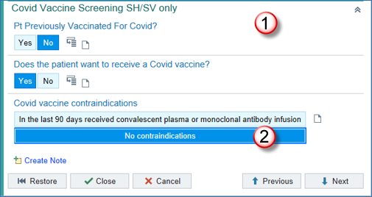
Education Steps:
1. Navigate to the Education activity. Three Covid education points have been added automatically.
- CDC v-safe (comes in 5 different languages)
- Covid-19 Disease Prevention
- Covid-19 Vaccine Consent Form
2. When the Pharmacy orders the vaccine, the First-Dose Education topic for the specific manufacturer/type of vaccine will also be added to the Education activity.
3. Select the checkboxes for any teaching points to be included in the education session.
4. The education handouts will be listed in the right pane.
- Click the arrow icons to print all necessary material for the patient.
5. Click the Document button and document the education outcome as you normally do.
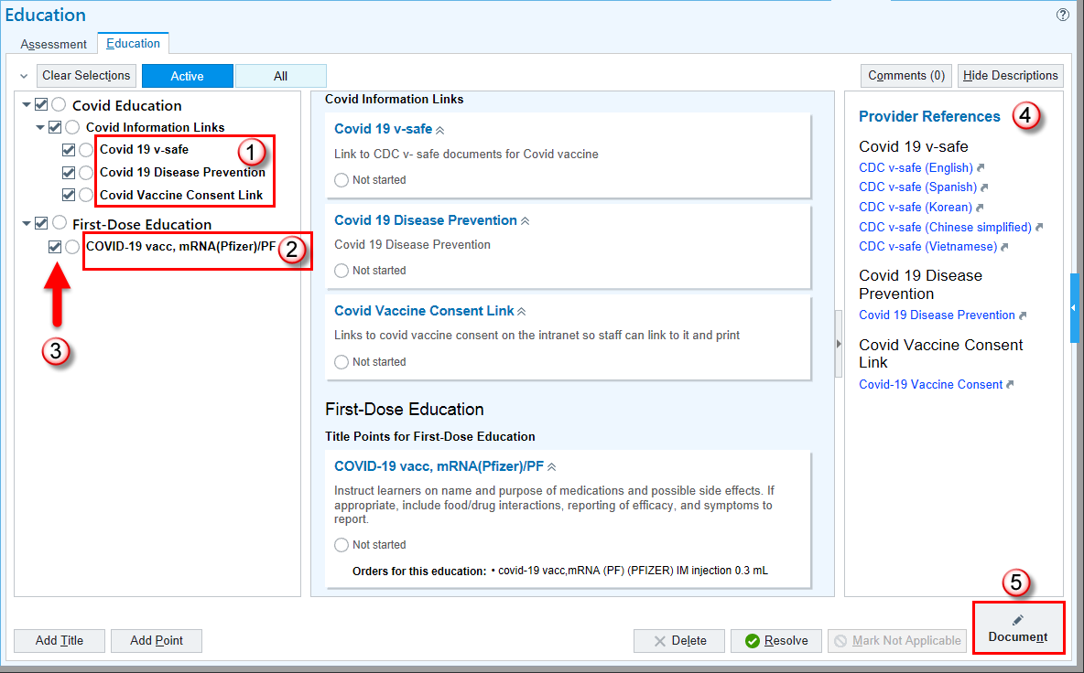

Just Prior to Administration:
1. Confirm the patient has signed the vaccine consent form and it has been placed in the chart.
- The consent can be printed from the Education activity tab (above)
- Or Click Here to Print Covid-19 Vaccine Consent
2. The RN must retrieve the Vaccine Administration Record (VAR) and the vaccine vial from the Pharmacy just prior to discharge.
*** If this is the patient’s second dose of a Covid-19 vaccine, it is important to know if the patient received the Pfizer or Moderna vaccine and the exact date of administration so this information can be conveyed to the pharmacist prior to picking up the vaccine vial.***
- Clinical support staff cannot handle the vaccine.
- The Pharmacy cannot deliver the vial to the floor.
- The vial cannot be tubed via the pneumatic system.
3. If the Pharmacy is closed, the vaccine vial and VAR can be obtained from the ED Omnicell.

Administration Steps:
The Pfizer vaccine vial must be diluted within 2 hours of removal from the refrigerator. The vaccine must be administered within 6 hours of removal from the refrigerator. The dose is 0.3 mL as specified in the MAR administration window. The Pfizer vaccine vial contains 6 doses but is to be treated as if it is a single dose vial; after drawing up the 0.3 mL dose, discard the vial with the remaining 5 doses.
1. Open the MAR administration window by scanning the patient armband label and the vaccine label.
2. Answer all required screening questions in the MAR Immunization Info section.
- If any contraindications, do not administer the vaccine until you have spoken to the physician.
- If no contraindications, administer the vaccine.
3. Select Initial Vaccine Administration to charge for the vaccine. 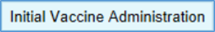
4. Monitor the patient for adverse reaction for 15-30 minutes after administration.

5. Fill out the VAR and give to the patient.  - Patient name  - Date of birth  - Medical Record Number (E number)  - Product name/Manufacturer  - Lot number  - Date vaccine received  - Hospital name | 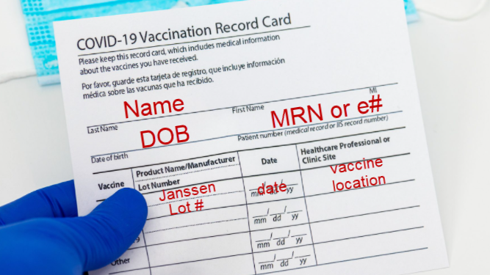

Vaccine BPA in the Discharge Navigator:

 | For your convenience: when you enter the Discharge navigator, if a patient has an order for the Covid-19 vaccine and the vaccine has not been administered on the MAR, you will see this BPA alert as reminder!  To resolve this BPA, click Acknowledged and document an Acknowledge Reason and click the Accept buttons. | 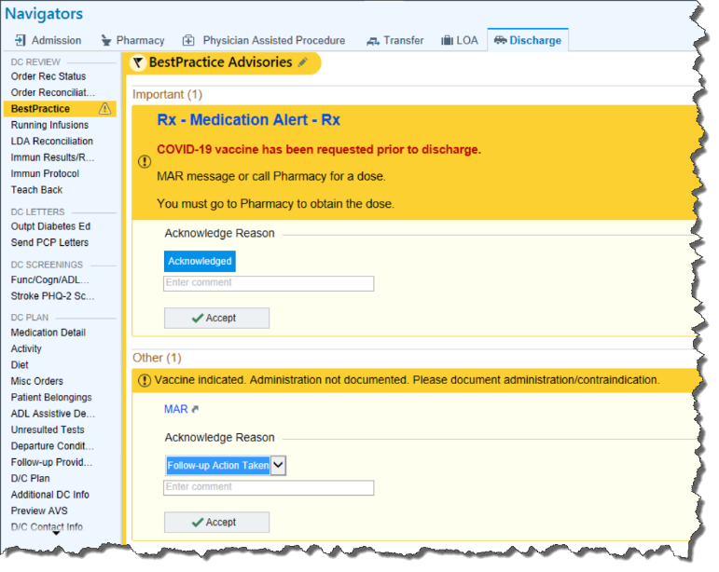
Vaccine Information in the AVS:
If a patient has received a Covid-19 vaccine at discharge, they will receive important information in their After Visit Summary (AVS). Review these items with the patient so they are aware of this information:
- The type of vaccine they received along with the date they received it.
  - This information is also available on the VAR card.
- Information about getting the second vaccine from a Kroger pharmacy.

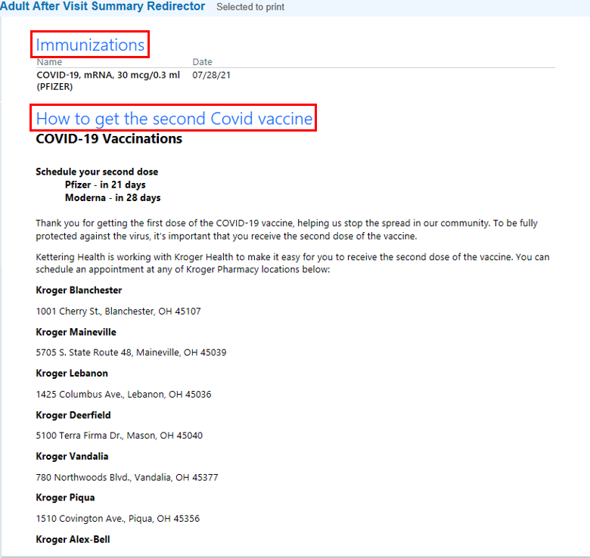

Do Not Print This Tip Sheet:
This process is new and is likely to change. For that reason, do not print this tip sheet! Always refer to this tip sheet on the Knowledge Base so that you will have the most recent workflow available.

